A simple TDD example - the Roman Calculator

This is a TDD example to make a Roman Numeral Calculator.
We will use Idle for Python 2.7.

We start with the simplest possible thing — TDD is very much an agile methodology, so we start to think about what the "minimum viable Roman numeral calculator" might do… What would be just slightly better than not having a calculator at all? How about one that can add 1 + 1?

- Now create a file called rncTest.py and put the following lines of code into it.

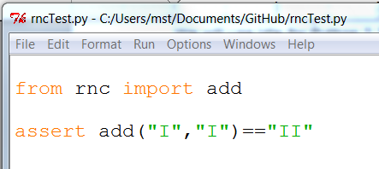

This is our first test for a minimum viable calculator

Let’s try running it. “What?”, I hear you say, “that’s totally pointless — we haven’t even made a rnc.py, or an add function, it’s just a waste of time to run the test now!”

There are different justifications for it. One is that, even though we could easily skip a bunch of steps in these easy cases, we just do it as practice, because it’s a great skill to have for when we get into the not-so-easy cases. Another is that, in purely practical terms, it really doesn’t waste any serious time, and it might even help us catch some early bugs — if there’s a syntax error in our tests, we may as well catch it right now rather than later.

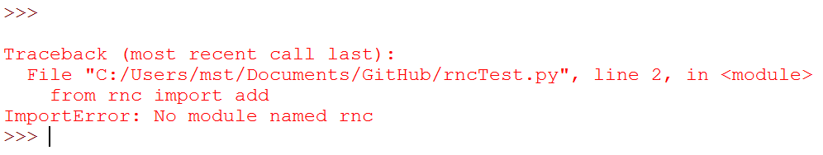

Once we have a failing test, the next thing to do is make the smallest possible code change that will get the tests closer to passing. The "Driven" bit in TDD means we let the tests tell us what to do. In this case, they’re complaining of an import error, so let’s fix that - and only that.

We can do it by creating an empty file called rnc.py

- Create a file called rnc.py in Idle and put your name and a comment at the top about the program. RNC is Roman Numeral Calculator.

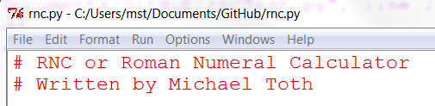
Now we can re-run our test!

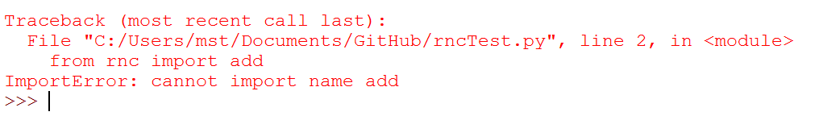
Progress! We’ve moved from one kind of ImportError to another one. Let’s fix that! Open up rnc.py and add 1 line of code:

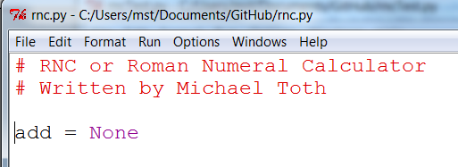

And re-run the test

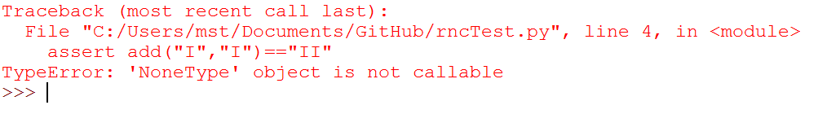
Yeah! Seriously! It’s perverse, isn’t it? Now, I’ll admit, perhaps in real life I would have jumped straight to defining a function called "add".

Do I really expect you to always write code like this? No. But I want you to always be able to.

These sorts of baby steps seem nonsensical when we’re dealing with an easy example like this, but once you start talking about making changes to a complex application, being able to use baby steps makes for a much less stressful way of coding.

Taking small steps, with constant reference to tests, gives us reassurance that we’ll go from code that works to code that still works without breaking anything.

By only making minimal changes, and justifying each change with reference to getting a test to pass, we make sure that every bit of your code is tested. It also tests the tests - running them frequently and seeing that they fail in the way you expect, makes sure that the tests really work the way you think they do.

So let’s get them a little further along:

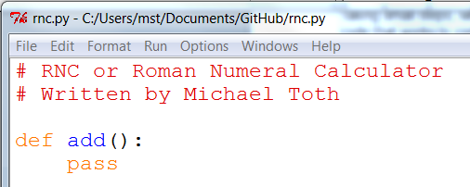

Now we expect a moan about arguments:

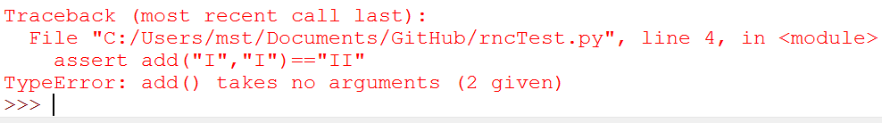
Let’s fix that:

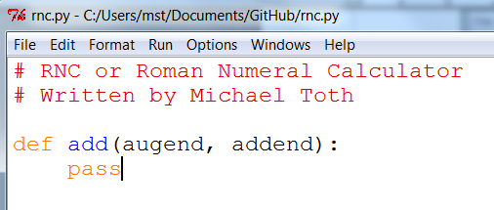

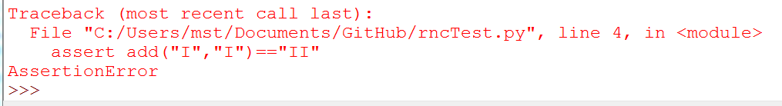
“AssertionError” isn’t very helpful - let’s make our tests a bit more verbose in their failure message:

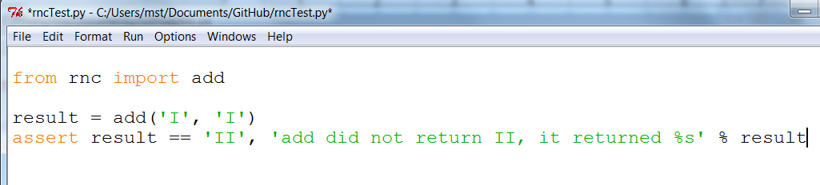
That’s a bit better:

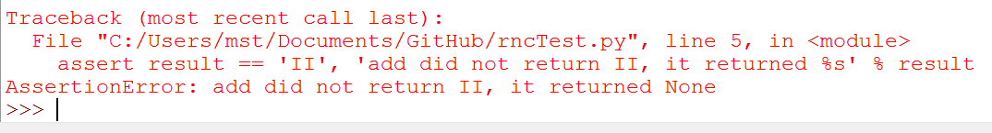
Writing our own error messages is a bit tedious though. Time to bring in some testing tools:

The Python unittest module

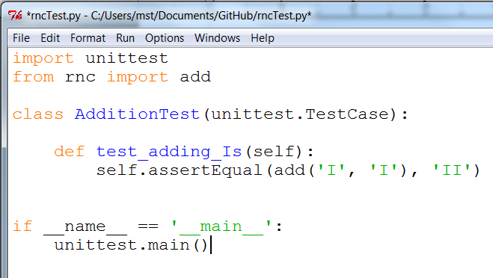
unittest is Python’s main built-in testing tool; it has lots of tools to help structure our tests, tools to run them and report passes and failures, and dozens of useful functions like assertEqual, which can help us to make assertions about our code, and report back with useful messages:

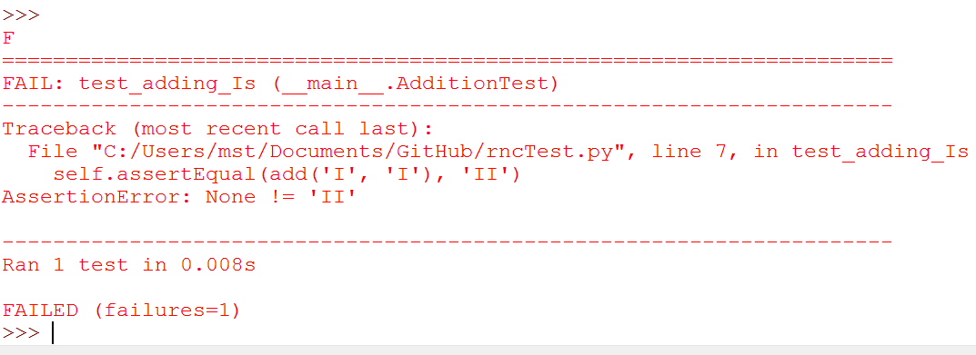
Tests in unittest are structured as methods on classes - the rule is that any method whose name starts with test will get run. unittest.main() will run all the tests in the current module, and print out any errors. You can see in the output that the failure message and traceback is neatly preceded by the class name (AdditionTest) and the test method name (test_adding_Is).

Now let’s see what we can do to get these tests passing:

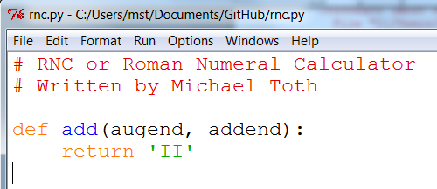

.
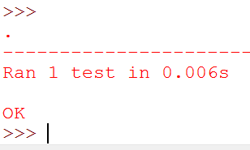

OK
Well, OK, the test is passing, but it’s pretty clear that we’ve cheated. Still, returning a hard-coded value like this is often a useful first step. If you’re dealing with complex code that’s built into a huge application, a function that “cheats” is still useful, because we can then check that it integrates with the rest of the application.

We know we’ve cheated, and it’s definitely nagging at us though. But, in order to justify changing the code, we have to write another test:

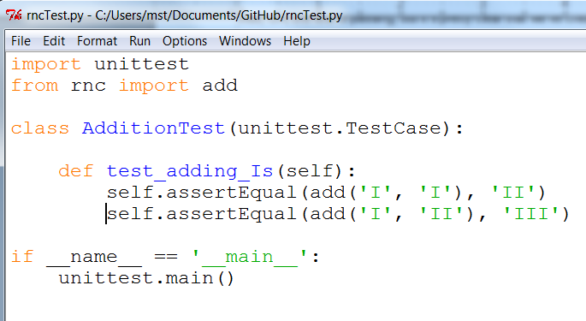
That gives us a failing test:

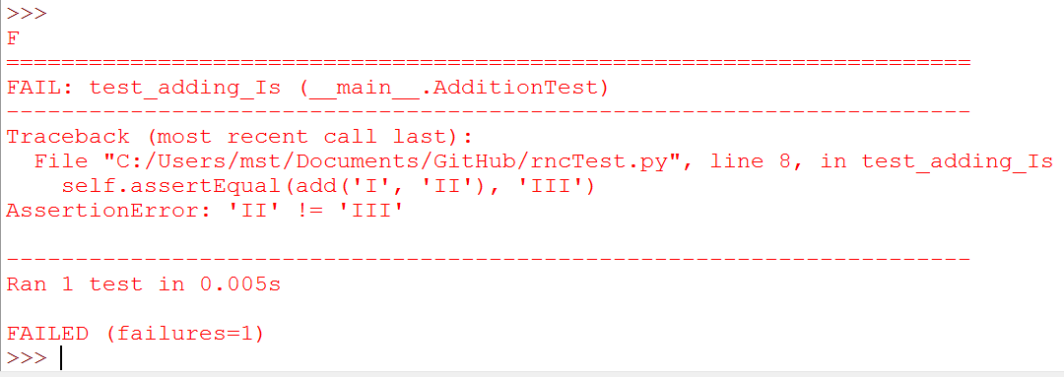
Which lets us have another crack at it, and write a slightly better implementation of add:

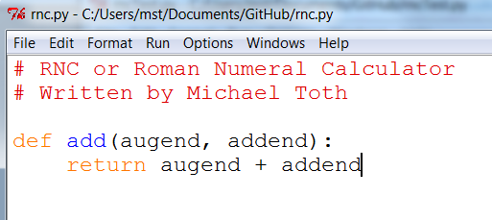

.

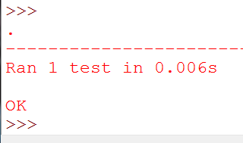
Hooray! A passing test. You might think it’s a slightly weird calculator so far, and that using string concatenation to implement addition of numbers isn’t likely to be a viable solution long-term, but for now, it works fine.

So far, we covered:

Using TDD to write the minimum viable Roman Numeral calculator

the First rule: Test First!

how to code with TDD: minimal,

Testing error cases and raising exceptions:

Let’s start by extending our tests. Our "minimum viable calculator" can currently add I + I, but calling it viable may be a bit of a stretch! For starters, although it’s only currently designed to add I’s, it will actually accept almost any input at all, and will probably return nonsense outputs.

Let’s make it return a sensible error if it gets input it doesn’t know how to handle. As usual, test-first, we start by specifying how we want the code to behave, from the point of view of the caller:

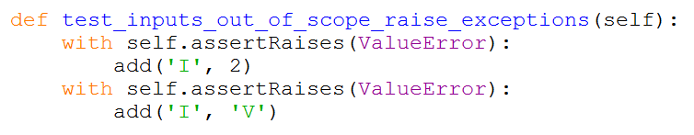
Add the above method to your tests. Since these tests are quite different from the tests for addition of I’s. Like all variable names, test names should be nice and descriptive, and in fact, they often are almost human-readable sentences. They should summarize what we want our code to do.

The next thing to introduce is assertRaises. This is another of unittest’s helper functions, and it works as a context manager. It allows us to run tests which we now will raise an exceptioin, and to make assertions about what type of exception we’ll get.

We’ve started by specifying two possible out-of-scope inputs: a non-Roman numeral, 2, and a Roman numeral which we don’t know how to compute yet, V. Let’s try running the tests:

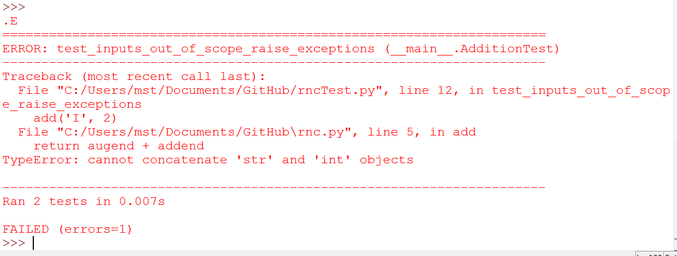
We now have two tests, of which one is failing. That allows us to go ahead and write some new code. The tests are complaining about a TypeError, so let’s get rid of it:

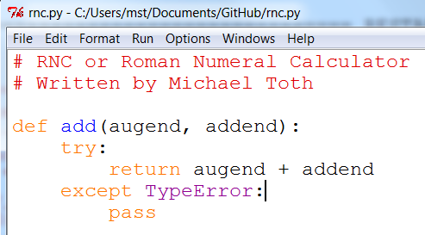
This produces a different error now

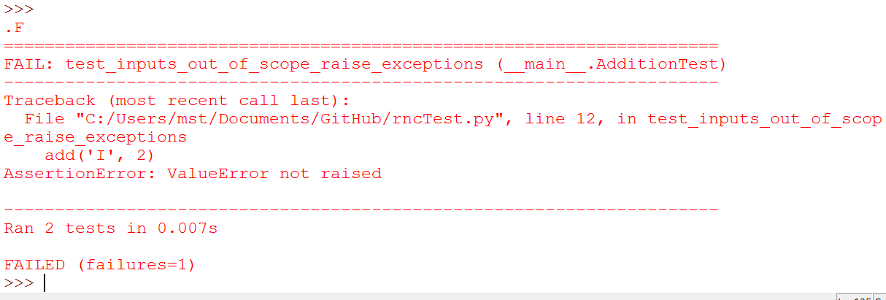

This is telling us the ValueError we wanted was not raised. (we excepted TypeError).

How tests can save us from stupidity:
Normally at this point I would insert a 'raise ValueError' inside the except block however to illustrate how tests can save us from stupidity, we will just do something stupid here.

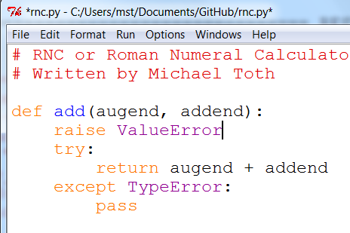

We are 'stupidly' raising a ValueError as the first line of the function.

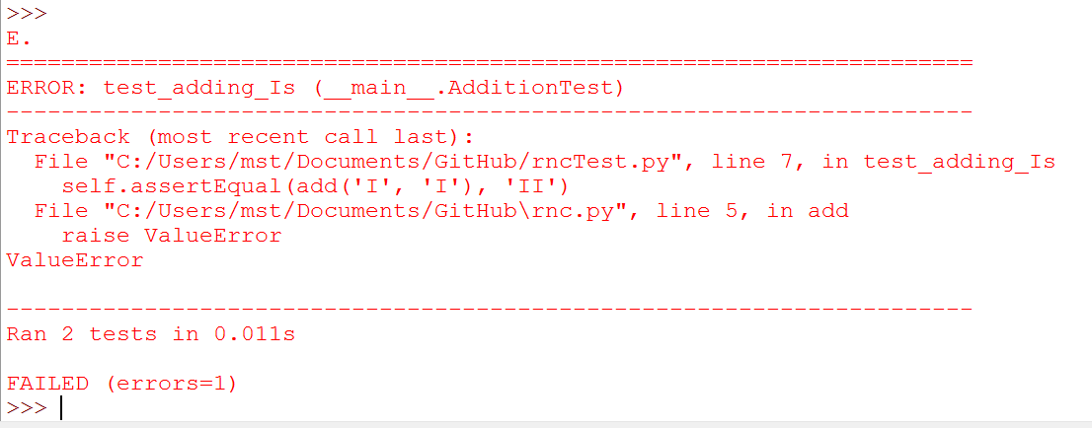
Our test for adding has failed, protecting us from our stupidity.

Try this code

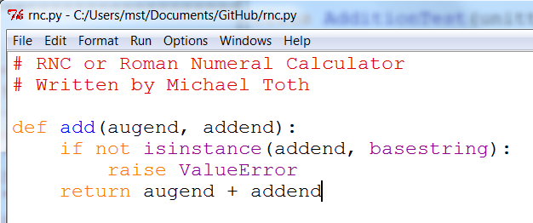
Let’s see if that will do the trick:

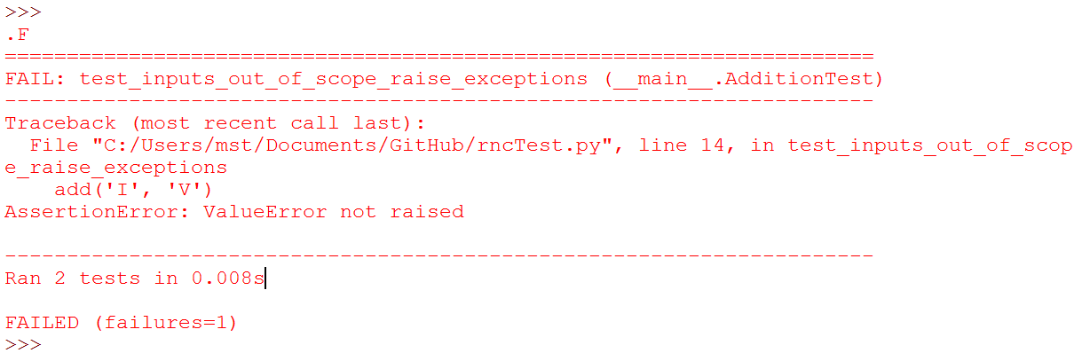
Our first assertion is now satisfied however our second one still needs to be dealt with.

Another incremental change:

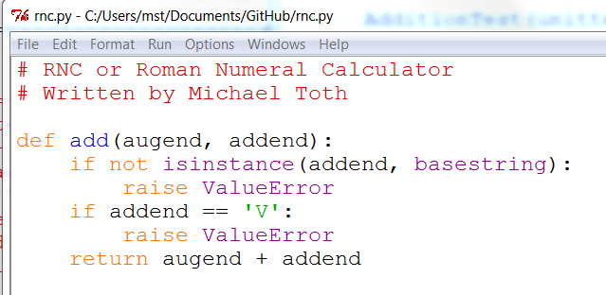
Now we pass.

These naive input validations aren’t really satisfactory though. We’re only checking on one of the inputs, for starters. Let’s extend our tests to cover a wider range of bad inputs, and justify some better input validation.

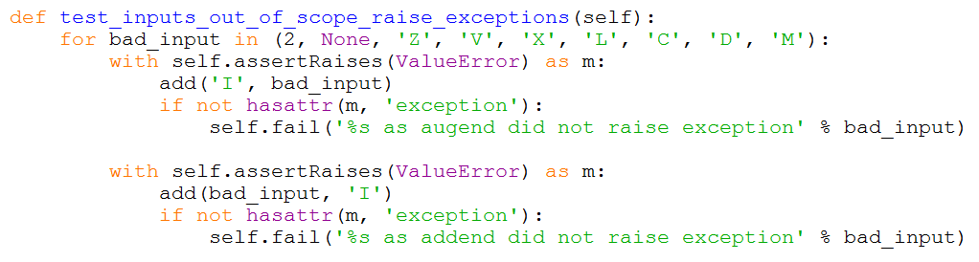

There’s a couple of new things there — you’ll see that assertRaises gives us a context manager, on which we can make assertions about the exceptions that was raised.

More importantly, it shows a common testing pattern, which is to put our tests in our loop in order to check several similar cases. When we do this, we need a way of figuring out which of the test values caused the error, so that’s why I’m using self.fail, which is a shortcut to failing out with a given message.

Let’s see how that does:

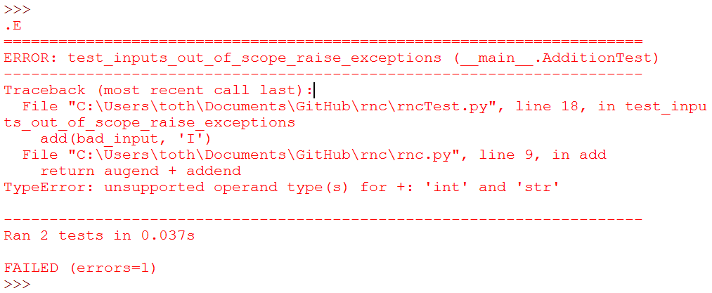

That’s telling us that we need to check both the augend and the addend for valid inputs. Here’s a minimal change:

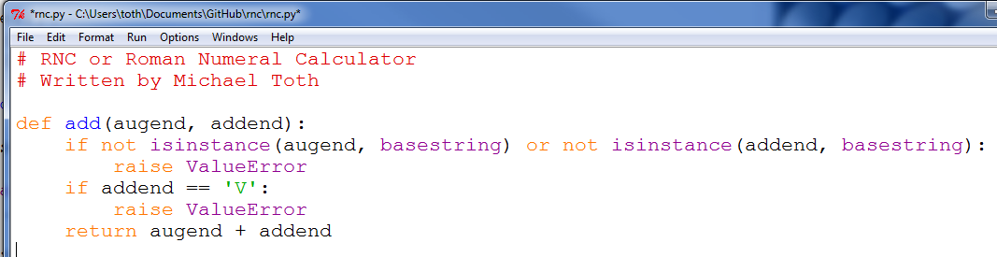We’re now getting into a familiar TDD cycle:

  - run the tests

  - make a minimal code change, driven by the test failure message

  - repeat until the tests all pass

Let’s play it out. Testing again:

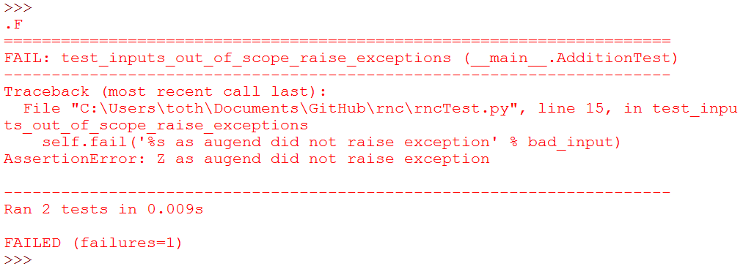
Let’s fix that:

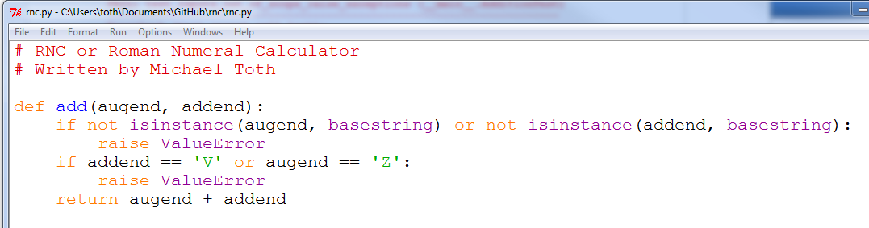

Ugly, but let’s see what the tests want:

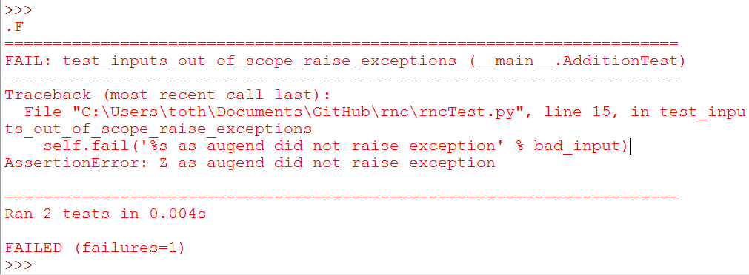

That justifies us to write some slightly cleverer input validation:

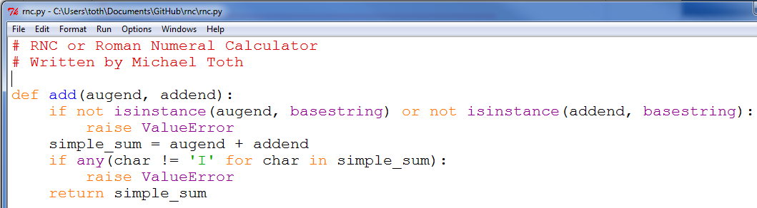And that gets the tests to pass!

Hooray. We covered testing for exceptions, we saw how tests can save us from our own stupidity, and we learned about looping through test values.

Next we’ll look at refactoring and driving design through

Using TDD to drive desgin

Let’s extend our tests to try and get our calculator to do more useful stuff. We’ll start by extending it to handle one more numeral, and then see if we can’t generalize to a full suite.

import unittest
from rnc import add

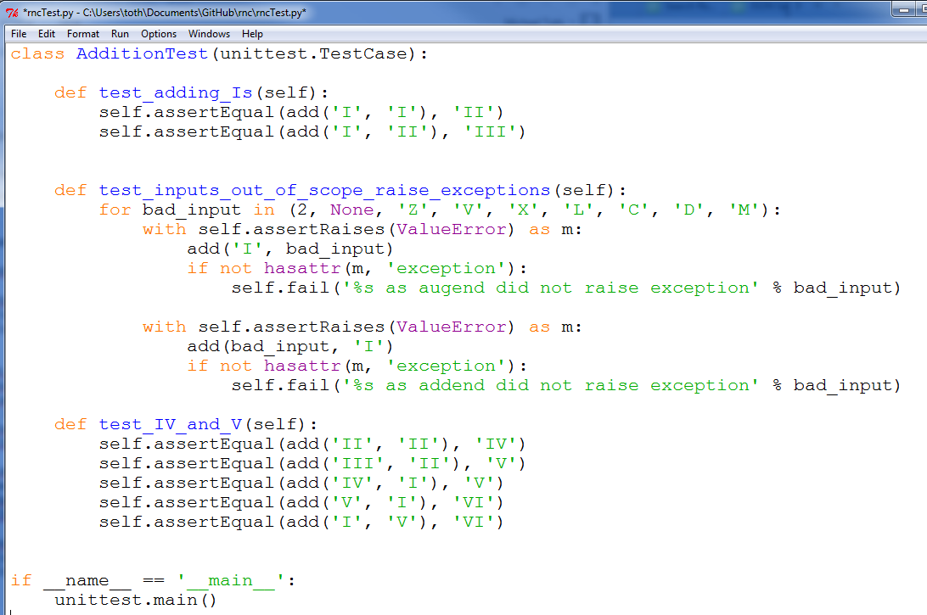Let’s try running that:

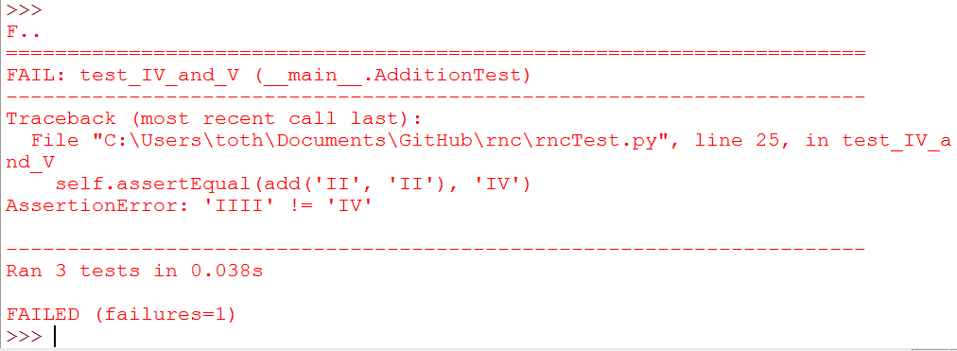Right - we’re not outputing IV correctly. Let’s fix that:

def add(augend, addend):
if not isinstance(augend, basestring) or not isinstance(addend, basestring):
raise ValueError
simple_sum = augend + addend
if any(char != 'I' for char in simple_sum):
raise ValueError

canonicalised_sum = simple_sum.replace('IIII', 'IV')
return canonicalised_sum
How about that?

F..
======================================================================
FAIL: test_IV_and_V (__main__.AdditionTest)
----------------------------------------------------------------------
Traceback (most recent call last):
File "book0/tests.py", line 25, in test_IV_and_V
self.assertEqual(add('III', 'II'), 'V')
AssertionError: 'IVI' != 'V'

----------------------------------------------------------------------
Ran 3 tests in 0.002s

FAILED (failures=1)
Ah. IV might work, but V is broken. Let’s fix it:

def add(augend, addend):
if not isinstance(augend, basestring) or not isinstance(addend, basestring):
raise ValueError
simple_sum = augend + addend
if any(char != 'I' for char in simple_sum):
raise ValueError

canonicalised_sum = simple_sum.replace('IIIII', 'V').replace('IIII', 'IV')
return canonicalised_sum

E..
======================================================================
ERROR: test_IV_and_V (__main__.AdditionTest)
----------------------------------------------------------------------
Traceback (most recent call last):
File "book0/tests.py", line 26, in test_IV_and_V
self.assertEqual(add('IV', 'I'), 'V')
File "/home/harry/Dropbox/book/book0/rome.py", line 6, in add
raise ValueError
ValueError

----------------------------------------------------------------------
Ran 3 tests in 0.001s

FAILED (errors=1)
Oops, looks like using a V as an input raises a value error. Let’s remove that case from our exception testing:

def test_inputs_out_of_scope_raise_exceptions(self):
for bad_input in (2, None, 'Z', 'X', 'L', 'C', 'D', 'M'):
with self.assertRaises(ValueError) as m:
add('I', bad_input)
[...]
And try some new code:

ROMAN_NUMERALS = ('I', 'V')
def add(augend, addend):
if not isinstance(augend, basestring) or not isinstance(addend, basestring):
raise ValueError
simple_sum = augend + addend

if any(char not in ROMAN_NUMERALS for char in simple_sum):
raise ValueError

canonicalised_sum = simple_sum.replace('IIIII', 'V').replace('IIII', 'IV')
return canonicalised_sum
How about that?

F..
======================================================================
FAIL: test_IV_and_V (__main__.AdditionTest)
----------------------------------------------------------------------
Traceback (most recent call last):
File "book0/tests.py", line 26, in test_IV_and_V
self.assertEqual(add('IV', 'I'), 'V')
AssertionError: 'IVI' != 'V'

----------------------------------------------------------------------
Ran 3 tests in 0.002s

FAILED (failures=1)
Looks like our naive addition code can’t handle IV as an input. Just as we canonicalise at the end of our add function, we probably need to simplify our numerals, stripping out any IV forms and replacing them with more computable 'IIII’s:

ROMAN_NUMERALS = ('I', 'V')
def add(augend, addend):
if not isinstance(augend, basestring) or not isinstance(addend, basestring):
raise ValueError

simple_augend = augend.replace('IV', 'IIII')
simple_addend = addend.replace('IV', 'IIII')

simple_sum = simple_augend + simple_addend

if any(char not in ROMAN_NUMERALS for char in simple_sum):
raise ValueError

canonicalised_sum = simple_sum.replace('IIIII', 'V').replace('IIII', 'IV')
return canonicalised_sum
How about that?

F..
======================================================================
FAIL: test_IV_and_V (__main__.AdditionTest)
----------------------------------------------------------------------
Traceback (most recent call last):
File "book0/tests.py", line 28, in test_IV_and_V
self.assertEqual(add('I', 'V'), 'VI')
AssertionError: 'IV' != 'VI'

----------------------------------------------------------------------
Ran 3 tests in 0.002s

FAILED (failures=1)
Ah, looks like our canonicalised sum isn’t clever enough to tell the difference between IV and VI. Order matters!

Here’s another excellent example of TDD. I think I need to figure out how to take the simple_sum, and order its digits so that the largest roman numerals come out first. I’m pretty comfortable with Python, so I have some sense that I can use the duck-typing of string as lists, and maybe Python’s built-in sorted and reversed functions… but if you asked me exactly how they work, without looking at the docs or an interepreter, I have to say I’m not 100% sure of how I’d do it… How does sorted apply to strings anyway? Thankfully, the magic of TDD means I don’t need to look at the docs, or open up an interpreter to try out some examples. I can simply try a few different options, directly in my code, and rely on the tests to tell me what I get right or wrong. Here’s how I went about it this time:

ROMAN_NUMERALS = ('I', 'V')
def add(augend, addend):
if not isinstance(augend, basestring) or not isinstance(addend, basestring):
raise ValueError

simple_augend = augend.replace('IV', 'IIII')
simple_addend = addend.replace('IV', 'IIII')

simple_sum = simple_augend + simple_addend

if any(char not in ROMAN_NUMERALS for char in simple_sum):
raise ValueError

ordered_sum = sorted(simple_sum)

canonicalised_sum = ordered_sum.replace('IIIII', 'V').replace('IIII', 'IV')
return canonicalised_sum
That gave me two test failures:

AttributeError: 'list' object has no attribute 'replace'
AttributeError: 'list' object has no attribute 'replace'
Ah, looks like sorted has produced a list instead of a string. Didn’t know it would do that. No matter:

ordered_sum = ''.join(sorted(simple_sum))
Any better?

AssertionError: 'IV' != 'VI'
Nope. How about this?

ordered_sum = ''.join(reversed(simple_sum))
…

AssertionError: 'IV' != 'VI'
Hm, no difference. That actually had me quite puzzled for a while, until I figured out that, of course, sorted actually sorts, whereas reversed just reverses, not reverse-sorts. TDD sure can help, if you’re (on occasion) a bear of little brain.

So we need both!

ordered_sum = ''.join(reversed(sorted(simple_sum)))
That gets the tests to pass

...
----------------------------------------------------------------------
Ran 3 tests in 0.001s

OK
So it looks like there are 5 parts to our roman numeral adder:

validating inputs

simplifying inputs by replacing 'IV’s with 'IIII’s

adding them together by simply concatenating the two numerals

sorting the result so that the higher numerals are at the beginning

finally, canonicalising the result by transforming any 'IIII’s back into 'IV’s and any 'IIIII’s into 'V’s.

The next stage is to get the calculator to do X. We might be tempted, at this point, to start refactoring - building out some helper functions for one or many of the 5 steps above. But there are a couple of useful sayings in TDD, which are pertinent at this point:

“YAGNI”

“3 strikes, then refactor”

“YAGNI” stands for “You ain’t gonna need it”. Programming is all about the joy of building stuff, and we enjoy noticing patterns, thinking of ways to generalise things, jumping in and adding another layer of indirection. But it’s all too easy to get carried away with this, and classes like ActionTemplateManagerFactoryFactory are not far away. TDD aims for simple code, and that simple sometimes means not generalising too soon. YAGNI and the 3 strikes rule are there to stop us from generalising too soon.

So, before we dive in and make a canonicalize function or a simplify_numeral function, let’s make sure we know what we want by seeing if we can get X to work, getting a second strike in, and we’ll be ready to refactor at the next numeral.

def test_IX_and_X(self):
self.assertEqual(add('V', 'V'), 'X')
self.assertEqual(add('V', 'IV'), 'IX')
self.assertEqual(add('VIII', 'I'), 'IX')
self.assertEqual(add('IX', 'I'), 'X')
self.assertEqual(add('X', 'I'), 'XI')
self.assertEqual(add('I', 'X'), 'XI')
self.assertEqual(add('X', 'V'), 'XV')
self.assertEqual(add('V', 'X'), 'XV')
self.assertEqual(add('X', 'X'), 'XX')
Let’s run those:

.F..
======================================================================
FAIL: test_IX_and_X (__main__.AdditionTest)
----------------------------------------------------------------------
Traceback (most recent call last):
File "book0/tests.py", line 32, in test_IX_and_X
self.assertEqual(add('V', 'V'), 'X')
AssertionError: 'VV' != 'X'

----------------------------------------------------------------------
Ran 4 tests in 0.002s

FAILED (failures=1)
Looks like we need to convert VV to X before returning:

canonicalised_sum = ordered_sum.replace('IIIII', 'V').replace('IIII', 'IV').replace('VV', 'X')
How about that?

self.assertEqual(add('V', 'IV'), 'IX')
AssertionError: 'VIV' != 'IX'
OK, we need to recognise IX just like we recognise IV:

canonicalised_sum = ordered_sum.replace('IIIII', 'V').replace('IIII', 'IV').replace('VV', 'X').replace('VIV', 'IX')
How’s that?

.E..
======================================================================
ERROR: test_IX_and_X (__main__.AdditionTest)
----------------------------------------------------------------------
Traceback (most recent call last):
File "book0/tests.py", line 35, in test_IX_and_X
self.assertEqual(add('IX', 'I'), 'X')
File "/home/harry/Dropbox/book/book0/rome.py", line 12, in add
raise ValueError
ValueError

----------------------------------------------------------------------
Ran 4 tests in 0.001s

FAILED (errors=1)
Oops, looks like we need to add X to our valid inputs:

ROMAN_NUMERALS = ('I', 'V', 'X')
What about now?

.F.F
======================================================================
FAIL: test_IX_and_X (__main__.AdditionTest)
----------------------------------------------------------------------
Traceback (most recent call last):
File "book0/tests.py", line 35, in test_IX_and_X
self.assertEqual(add('IX', 'I'), 'X')
AssertionError: 'XII' != 'X'

======================================================================
FAIL: test_inputs_out_of_scope_raise_exceptions (__main__.AdditionTest)
----------------------------------------------------------------------
Traceback (most recent call last):
File "book0/tests.py", line 16, in test_inputs_out_of_scope_raise_exceptions
self.fail('%s as augend did not raise exception' % bad_input)
AssertionError: X as augend did not raise exception

----------------------------------------------------------------------
Ran 4 tests in 0.001s

FAILED (failures=2)
Urg, two fails. One just reminds us that we need to change our scope tests if we change our scope!

def test_inputs_out_of_scope_raise_exceptions(self):
for bad_input in (2, None, 'Z', 'L', 'C', 'D', 'M'):
Now what?

.F..
======================================================================
FAIL: test_IX_and_X (__main__.AdditionTest)
----------------------------------------------------------------------
Traceback (most recent call last):
File "book0/tests.py", line 35, in test_IX_and_X
self.assertEqual(add('IX', 'I'), 'X')
AssertionError: 'XII' != 'X'

----------------------------------------------------------------------
Ran 4 tests in 0.006s

FAILED (failures=1)

